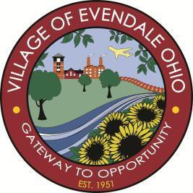

Village of Evendale

Special Council Meeting
10500 Reading Road, Evendale, Ohio
September 4, 2018
5:30 pm

- Pledge of Allegiance
- Roll Call
- Executive session in accordance with ORC 121.22- For the purpose of considering the compensation of public employees.
- Adjourn

