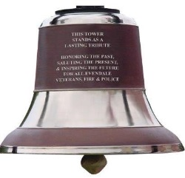
Veterans, Fire and Police Memorial Bell Tower

To have the plaques and bricks in place for the dedication of the bell tower on Memorial Day, all orders must be received no later than March 31, 2017

Name: _______________________________________________________________

Address: _____________________________________________________________

City, State, Zip: ________________________________________________________

Phone Number: ___________ Email: _____________________________________

Item you wish to purchase: __________________ Amount Enclosed: $___________

Text –up to 14 characters each line
Each letter, punctuation, and space is considered one character

☐ ☐ ☐ ☐ ☐ ☐ ☐ ☐ ☐ ☐ ☐ ☐ ☐ ☐
☐ ☐ ☐ ☐ ☐ ☐ ☐ ☐ ☐ ☐ ☐ ☐ ☐ ☐
☐ ☐ ☐ ☐ ☐ ☐ ☐ ☐ ☐ ☐ ☐ ☐ ☐ ☐
☐ ☐ ☐ ☐ ☐ ☐ ☐ ☐ ☐ ☐ ☐ ☐ ☐ ☐
☐ ☐ ☐ ☐ ☐ ☐ ☐ ☐ ☐ ☐ ☐ ☐ ☐ ☐
☐ ☐ ☐ ☐ ☐ ☐ ☐ ☐ ☐ ☐ ☐ ☐ ☐ ☐

Cost
4X8 Resident Veteran Bronze Plaque (3 lines) - $150.00
4X8 Non-resident Veteran Bronze Plaque (3 lines) - $300.00
8X8 Brick (up to 6 lines) - $150.00
4X8 Brick (3 lines) - $75.00

ADDITIONAL ITEMS AVAILABLE FOR PURCHASE

Naming Rights for the Bell $25,000.00
Naming Rights for the Clock (4) $15,000.00
Naming Rights for the Carillon $15,000.00
Benches for Veterans (4) $5,000.00/each
Small Replica Bells $60.00

Make checks payable to: Village of Evendale
Mail to: Evendale Bell Tower, 10500 Reading Road, Evendale, Ohio 45241
***We can only accept cash or check***

We will continue to sell plaques and bricks after the deadline of March 31st. Order forms are available on our website, Recreation Center and the Administration Office.

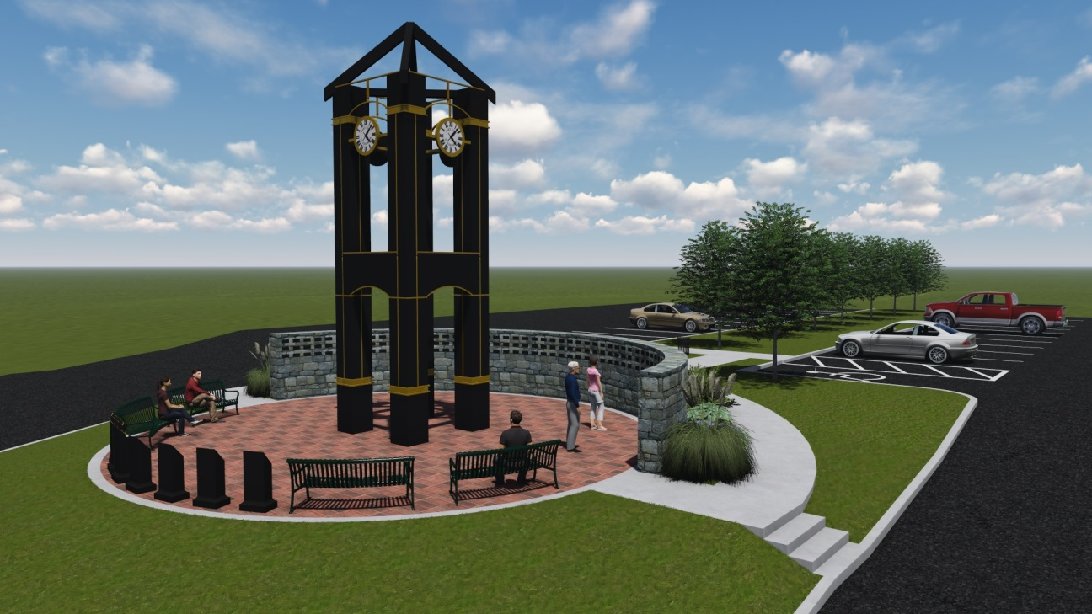

For Office Use Only

Order # __________ 4X8 Brick ☐ 8X8 Brick ☐ Plaque ☐ Bench ☐ Bell ☐

Payment of $ __________________ Received __________ __________ By ______________________________

Confirmation sent out on ____________________________________ By _________________________________

